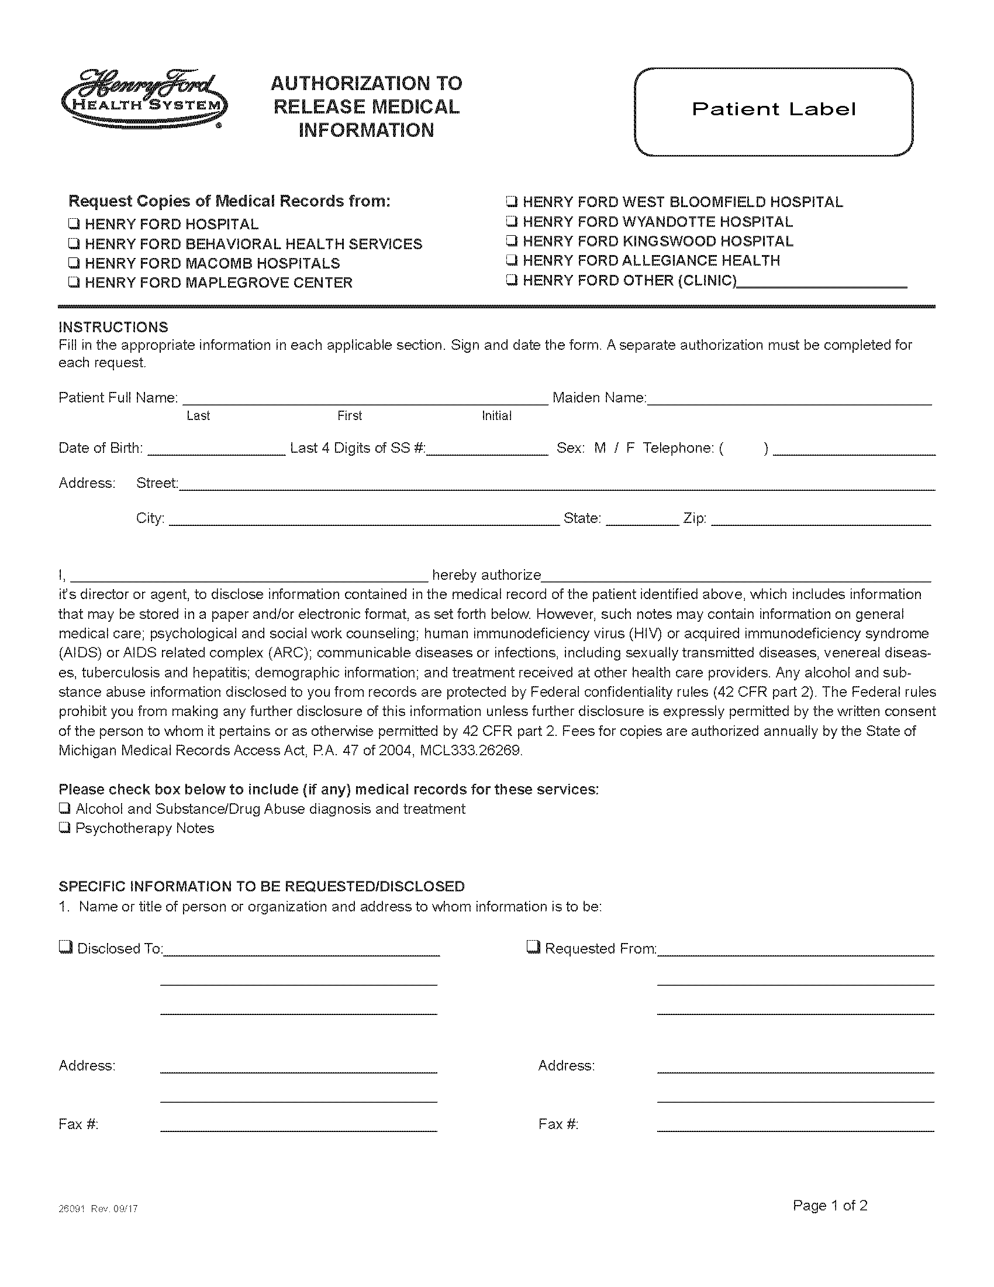
Batman
01/01/1979
xxx-xx-5555
Secret Location Under Office Building
Gotham
NJ

Batman
University of Michigan Hospital and Health Center
X
Axiom Requisition Copy Service
2869 Jolly Road
Okemos, MI 48864
PH: (877) 886-5090
X
University of Michigan Hospital and Health Center
2901 Hubbard Street
Room 2722
Ann Arbor, MI 48109-0000
X
X
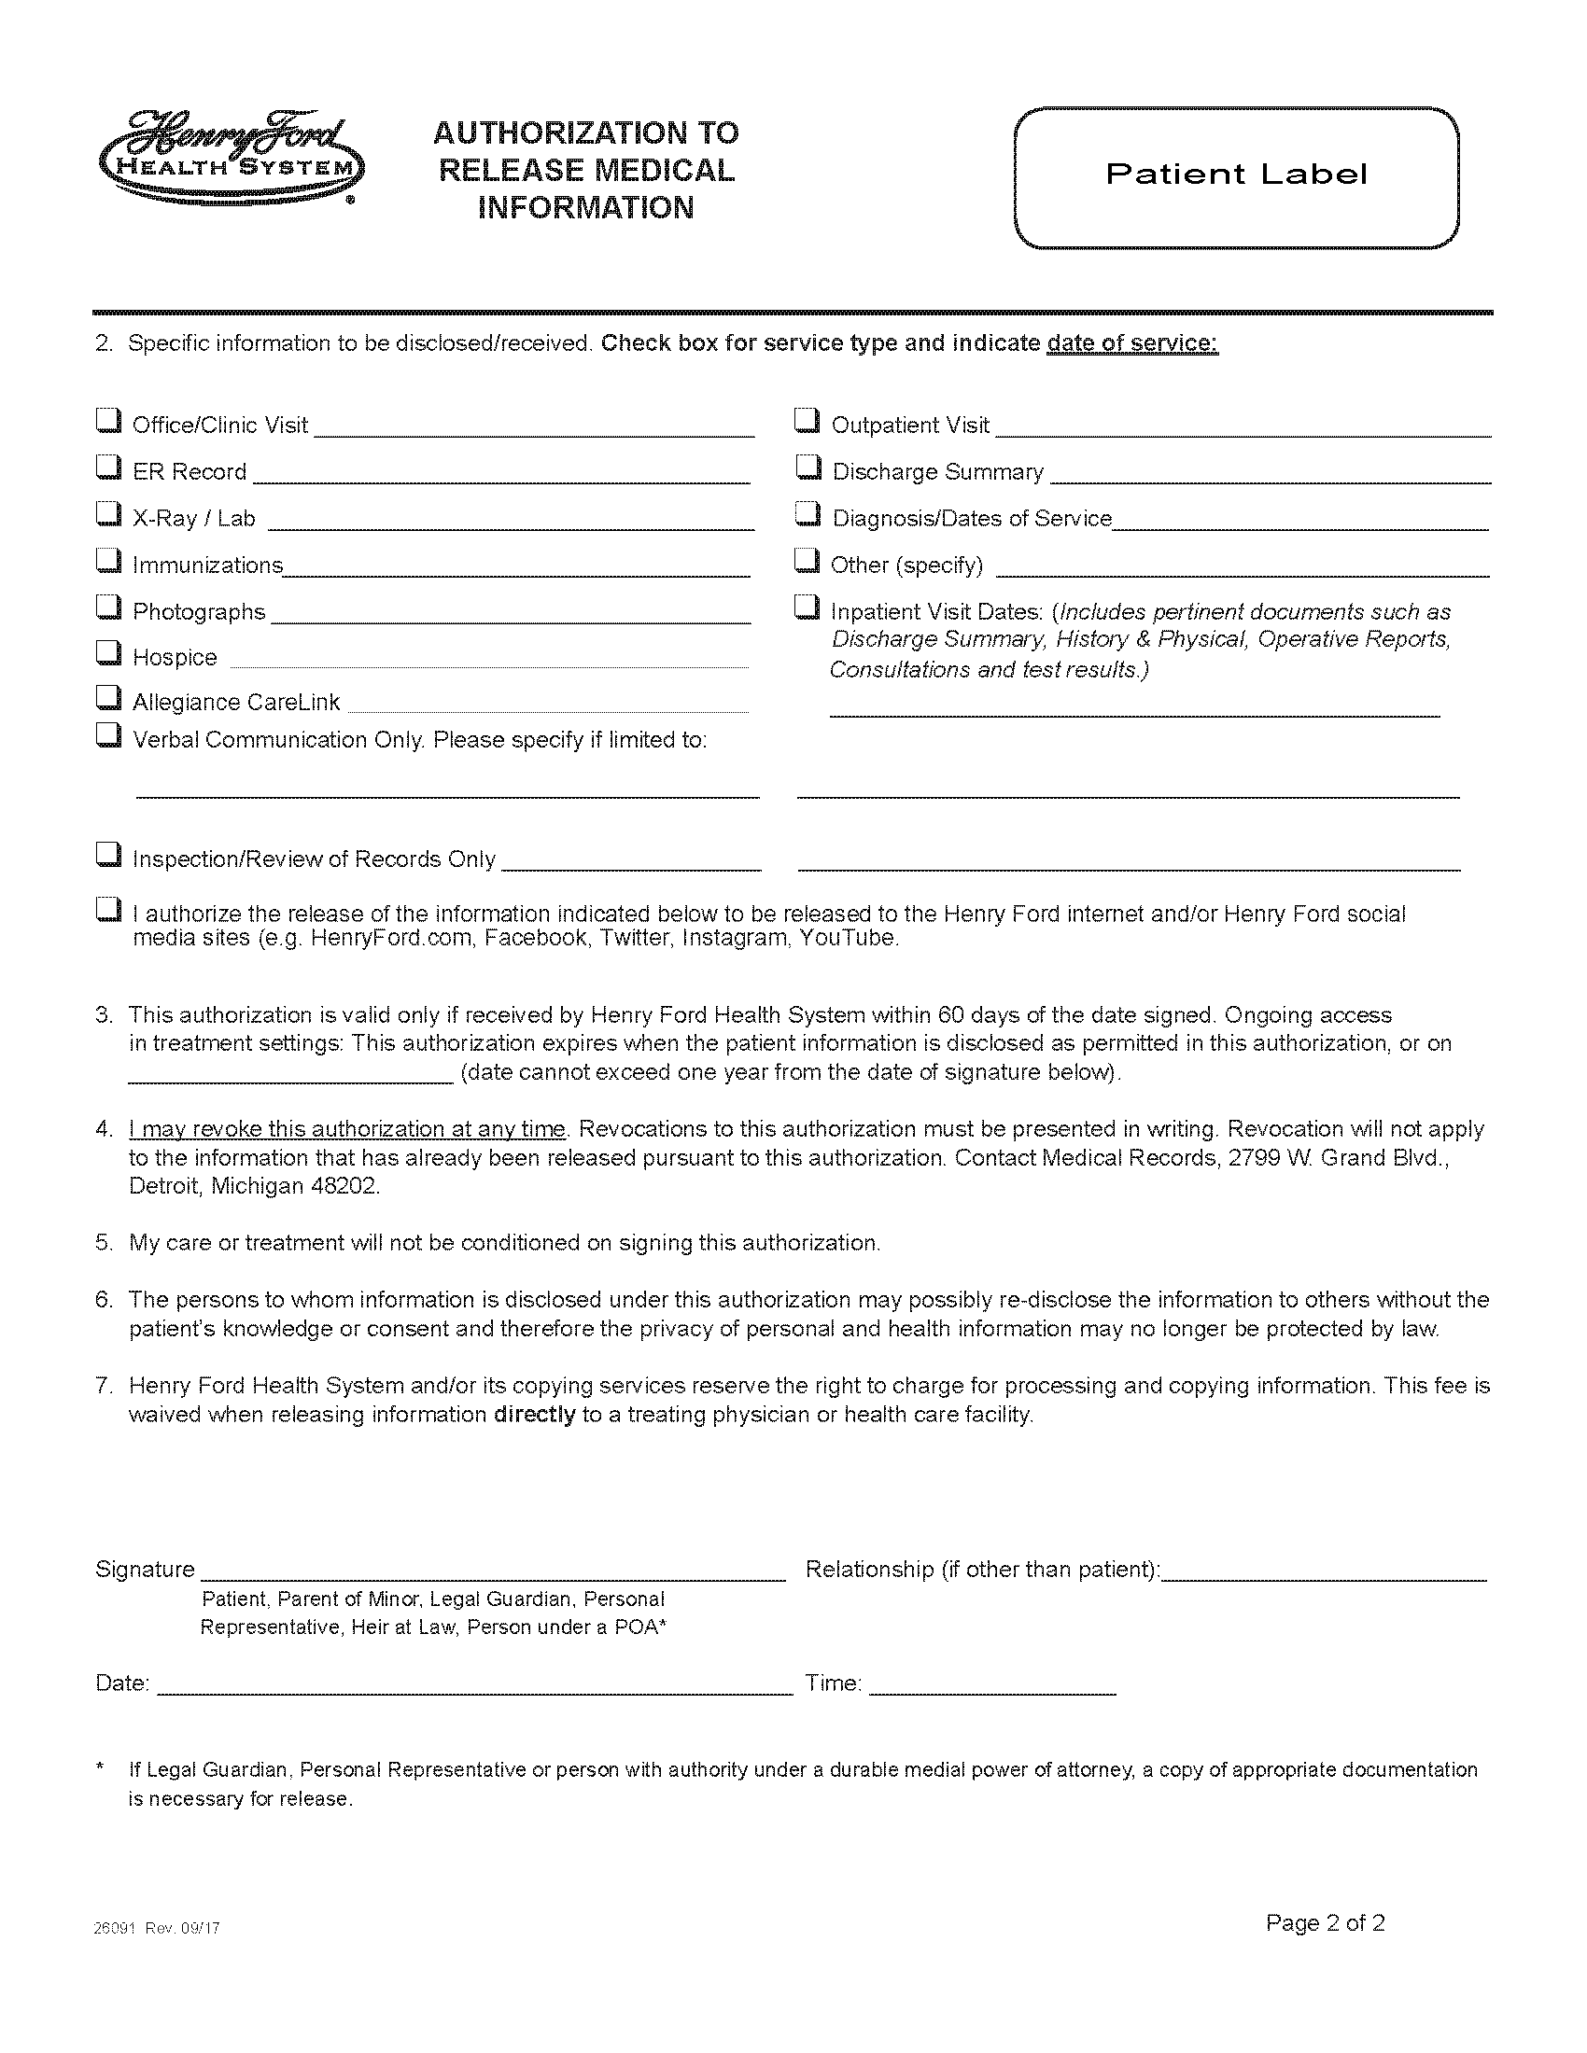
End of Legal Case
FROM 01/01/1979 TO PRESENT: Any and all MEDICAL RECORDS, including but not limited to patient history form(s), reports, etc. pertaining to Batman SSN: xx-xx-5555, DOB: 01/01/1979.
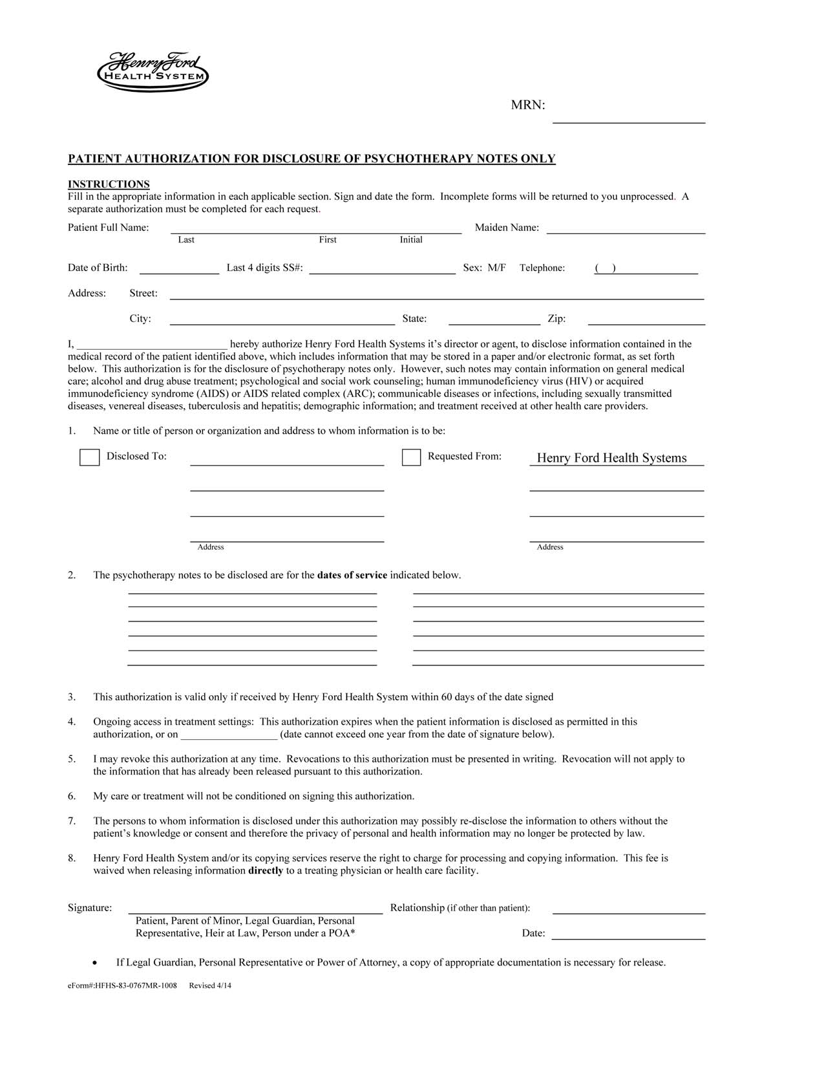
Batman
01/01/1979
xxx-xx-5555
Secret Location Under Office Building
Gotham
NJ

Batman
X
Axiom Requisition Copy Service
2869 Jolly Road
Okemos, MI 48864
PH: (877) 886-5090
X
University of Michigan Hospital and Health Center
2901 Hubbard Street
Room 2722
Ann Arbor, MI 48109-0000
FROM 01/01/1979 TO PRESENT: Any and all MEDICAL RECORDS, including but not limited to patient history form(s), reports, etc. pertaining to Batman SSN: xxx-xx-5555, DOB: 01/01/1979.
End of Legal Case

